1st Step: Log into POWER SCHOOL Parent & Student Portal (on district website right hand column under Quick Links): this is where you can access your child’s schedule.

Username: _________(student lunch number)

Password: _________(student lunch number)

Step 2: Look for WINDOW ROCK HIGH SCHOOL and click on it ( District website)

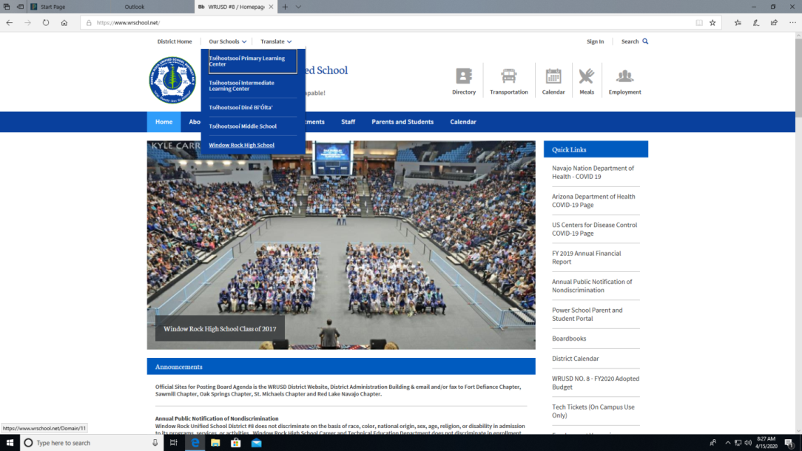

Step 3: Go to Departments

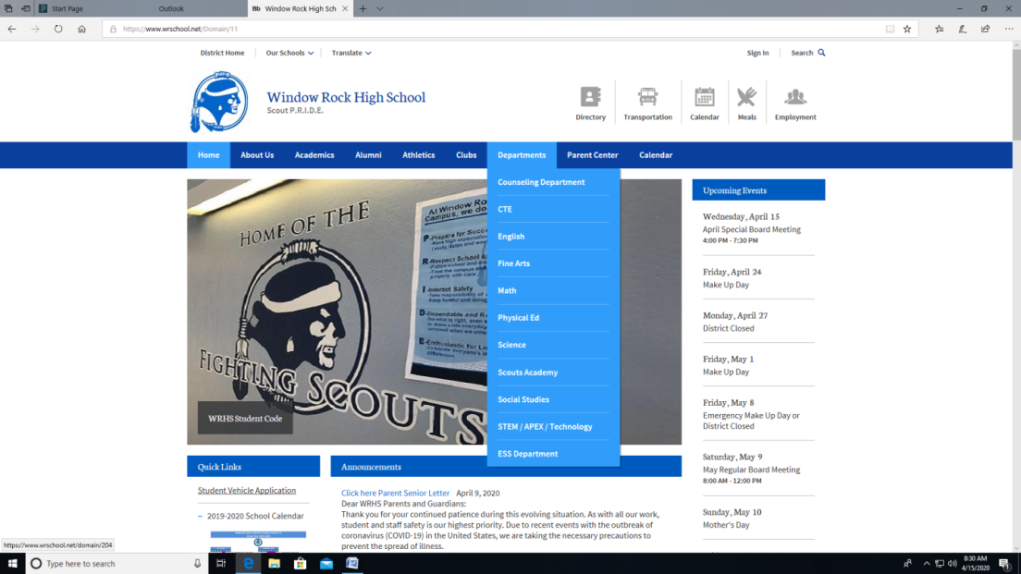

Step 4: Click on which subject you are looking for and select your Subject and teacher website to access material. Any questions you may email the teacher.

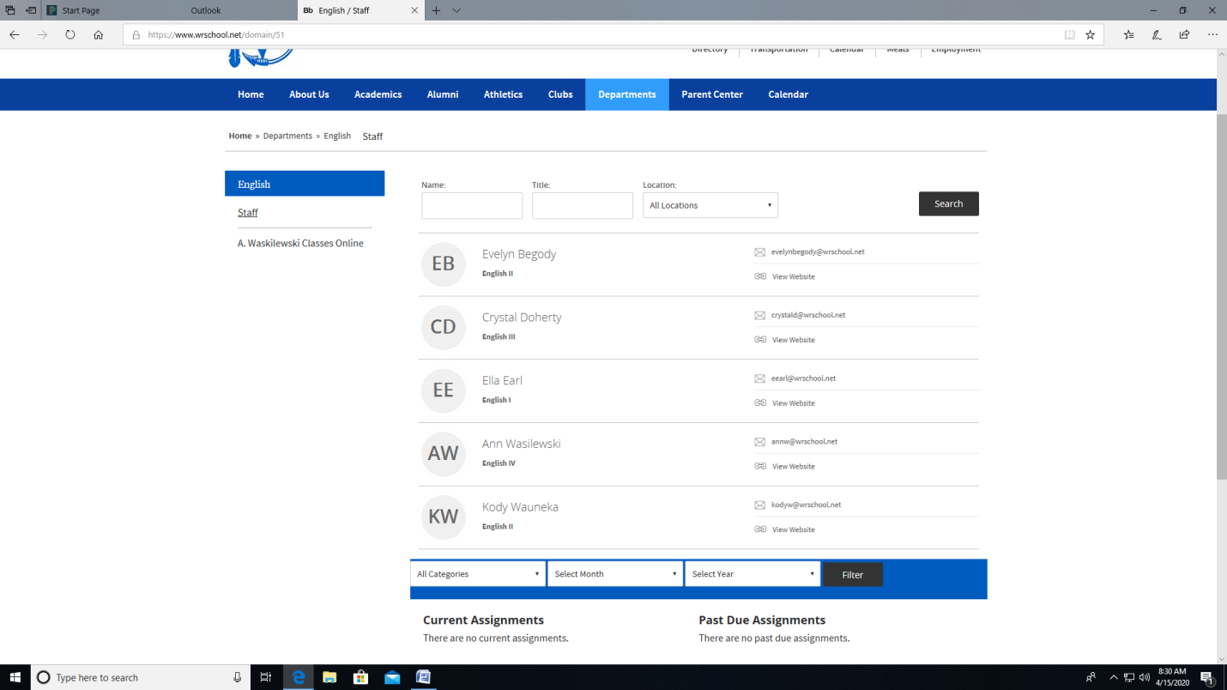

If you have question with Power School and/or need to set up your parent account please contact Marita Nez, Parent Liaison at 928-729-7040.

If you have question with your classes, email your teacher.

Thank you have a wonderful day